

WiFi Gateway Manual
Rev 1.3

Table of Contents
Table of Contents 2
1. Introduction 3
2. Installing Gateway 4

Introduction
The iobeam gateway provides many features and functions beyond a simple WiFi access point. Advanced usage reporting, content filtering, scheduled usage, internal web administration interface and segmentation along with a solid state Linux operating system which communicates with our network operating center, is combined to create a complete and flexible commercial grade hotspot venue.

The iobeam gateway has two internal Ethernet adapters and one internal WiFi adapter with a 5dBi antenna.

Each iobeam gateway comes with mounting hardware. We recommend you mount the unit indoors and central to your user location.

Eth0 connects to your switch/router; segmenting the public WiFi network from your private wired LAN.

Eth1 can be used to expand your wireless network over your property. You can connect external access points to this interface. Network traffic over this interface is on a separate network segment from the local LAN as well as the wireless traffic originating from the internal wireless access point. It is possible to set up special routing rules to allow printing and file sharing from all network subnets.

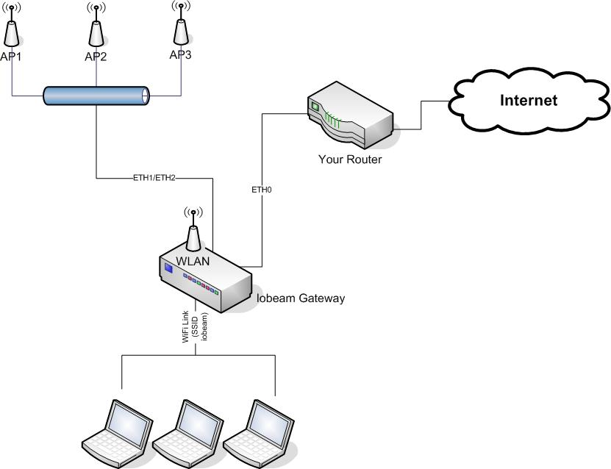

Installing Gateway
  - To install the gateway for the first time, connect ETH0 to your existing network.

  - From a wireless PC or laptop, configure the wireless card to connect to the iobeam access point. By default, the SSID is iobeam and WEP encryption is disabled. DHCP is used to issue your wireless device an IP address. Further instructions on how to configure your wireless laptop or PC can be obtained from the manufacturer’s manual or web page.

  - Open a web browser and navigate to the following address:
http://172.16.1.1:7027/gwadmin/

You should see the following screen.

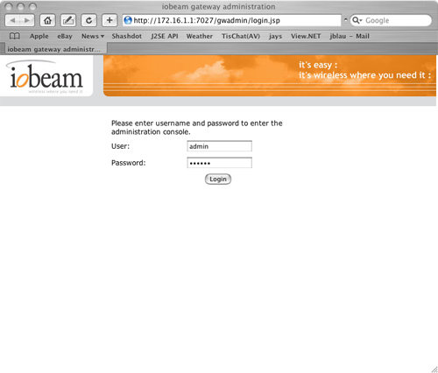

  - Log into the Gateway Administration page using the default user name and password.

User: admin
Password: iobeam

  - Click ‘Settings’ and navigate to Public Network Settings at the bottom of the page.

  - Your network administrator should provide you the information to enter in this section. For the gateway to operate properly, your network administrator must open port 7027 on your network firewall, if one exists. See section <<TODO>> for more information on firewall configurations.

  - To save your settings, click the ‘Set’ button. You must power-cycle your iobeam gateway for your changes to take effect.

